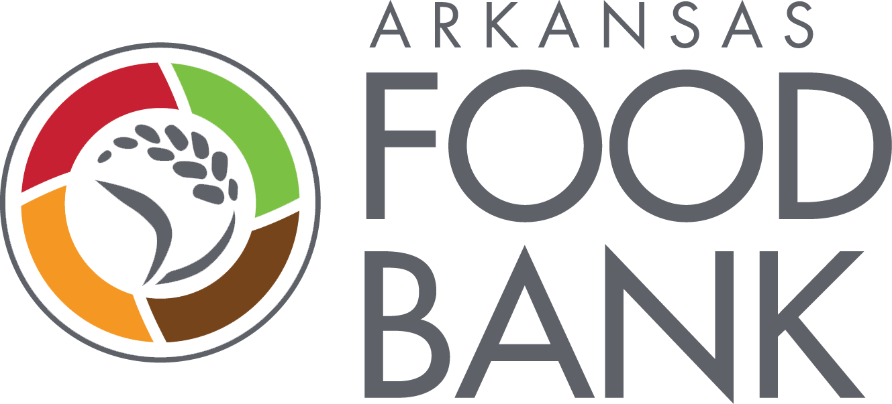 WRITTEN CLEANING SCHEDULE 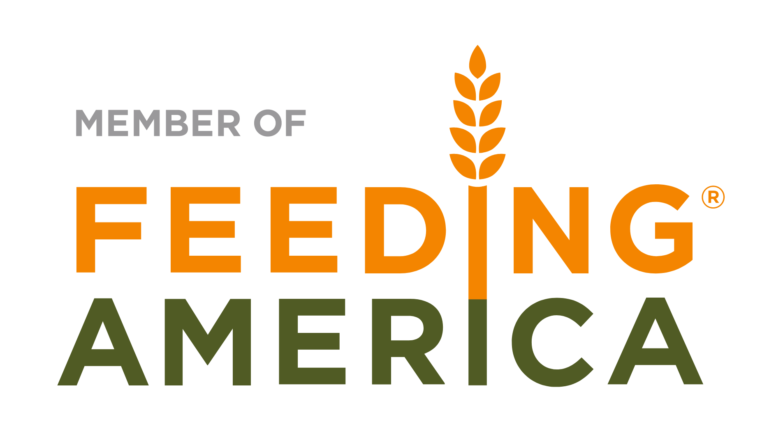
Agency Name____________________________________________________________________ Month_______________________ Year______________
Week of Month | Date of Cleaning | Type of Cleaning | Comments | Person Responsible | Signature

Instructions: THIS INSTITUTION IS AN EQUAL OPPORTUNITY PROVIDER
- Federal guidelines require a weekly written schedule of cleaning in food storage and preparation areas.
- The written cleaning schedule should reflect that all cleanings have indeed been conducted and documented.
- Copies of this schedule should be placed in Agency Files onsite and should be provided to the Arkansas Foodbank as part of the OnSite Review Process as requested.

